**Name : Xiao Ma**

**Part-1 : Linear Interpolation**

1. Insert your linear interpolated test image(hope.jpg) here:

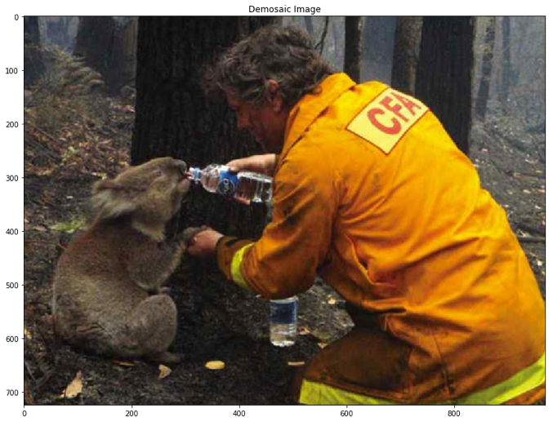

Figure 1 Deomosaic image with linear interpolation

1. Display the map/plot of all the 3 training images here:

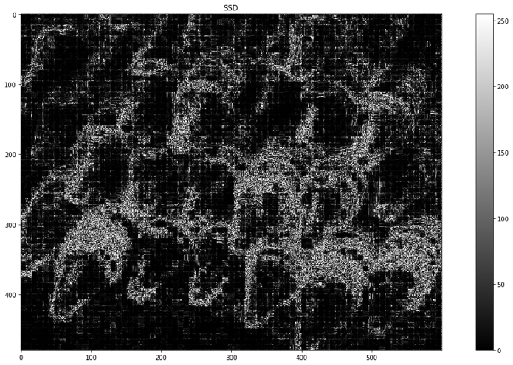

Figure 2 COLOR MAP OF SQUARE DIFFERENCE OF Crayons WITH LINEAR INTERPOLATION

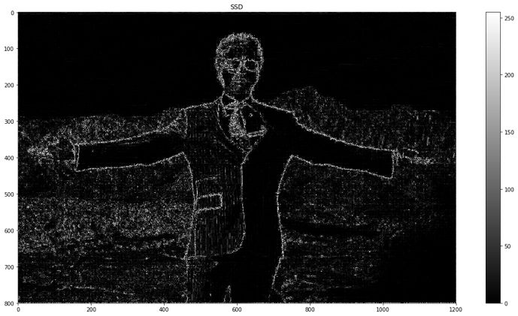

Figure 3 COLOR MAP OF SQUARE DIFFERENCE OF TONY WITH LINEAR INTERPOLATION

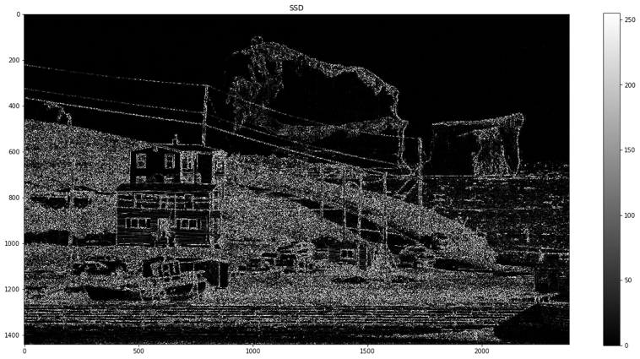

Figure 4 COLOR MAP OF SQUARE DIFFERENCE OF ICEBURG WITH LINEAR INTERPOLATION

1. Post close-up of any artifacts you came across.

* The square difference shows that the linear interpolation has significant artifacts at the boundary of an objects.
* With a more colorful image, the more artifacts increase, as shown in Figure 2 with the crayons picture containing more color than the other two, the SSD map shows relative large error
* The linear interpolation approach captures parts of the picture with uniform color pretty well. This is because that with the uniform color, the variation of the color in this region is realtive small, the linear interpolation is more accurate. (for example Figure2 Tony ‘s background ,the error is small).

1. Average_per_pixel error and Max_pixel_error for each of 3 training images :

|  |  |  |
| --- | --- | --- |
| Image | Average_per_pixel_error | Max_pixel_error |
| Crayons | 211.95443836805555 | 53478.125 |
| Tony | 57.5956853515625 | 36891.5625 |
| Iceberg | 114.55224648550471 | 30331.5625 |

**Part-2 : Freeman Method**

1. Insert your Freeman Method test image(hope.jpg) here:

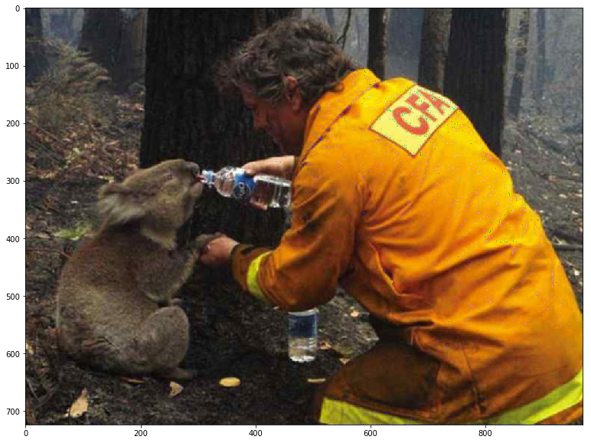

Figure 5 Demosaic of Test Image Hope with Freeman Approach

1. Display the map/plot of all the 3 training images here:

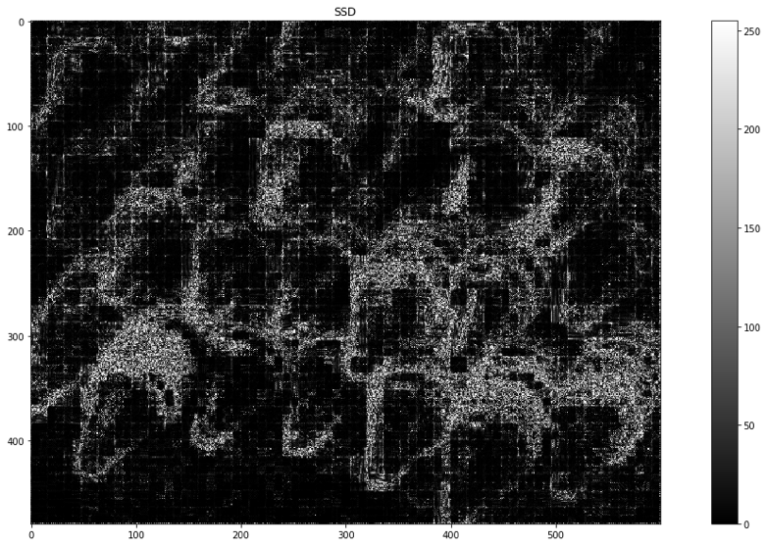

Figure 6 Color Map of Square Difference of CRAYON wiht FREEMAN Approach

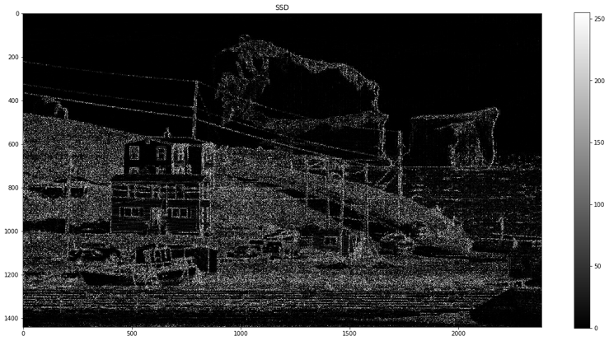

Figure 7 Color MAP of Square Difference of ICEBERG with FREEMAN APProach

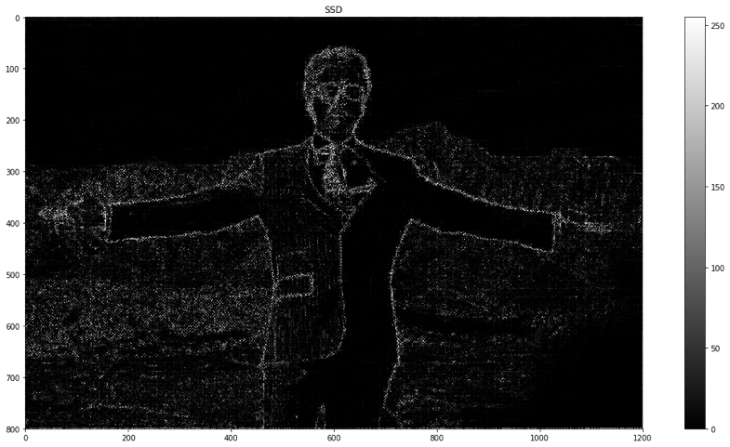

Figure 8 Color Map of Square Difference of Tony with Freeman Approach

1. Post close-up of any artifacts you came across.

* The Freeman method performs better than the linear interpolation in demosaicing the images.
* There are still artifacts arrise at the boundary of objects.
* The overall average per pixel error decrease almost by half using the Freeman approach than the linear interpolation
* Still with more colorful image, the less accurate the Freeman approach is,

1. Average_per_pixel error and Max_pixel_error for each of 3 training images :

|  |  |  |
| --- | --- | --- |
| Image | Average_per_pixel_error | Max_pixel_error |
| Crayons | 142.63010438368056 | 47857.625 |
| Tony | 28.8272189453125 | 32278.0 |
| Iceberg | 72.9752010339409 | 33839.5625 |

**Part-3 : Images of your choice**

1. Post 2 images your choice here and the corresponding error maps of your outputs with the Freeman method.

* Forbidden City Image:

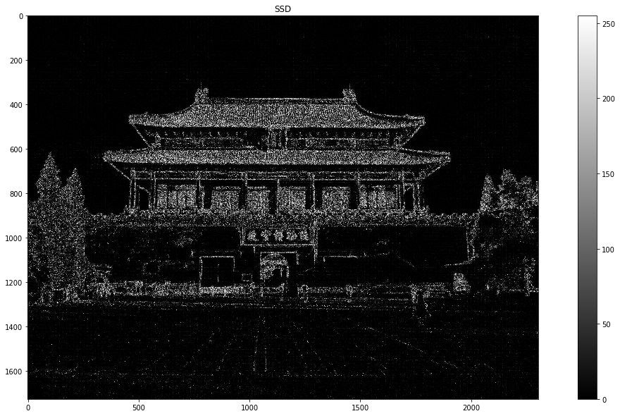

Figure 9 Color Map of Square Difference of FOrbidden City with Freeman Approach

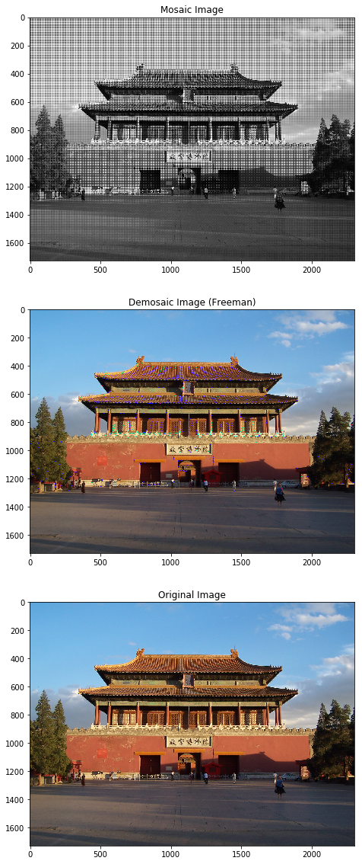

Figure 10 (Top) MOsaic image (Mid) Demosaic image with Freeman Approach (Down) Original Image

* UIUC image:

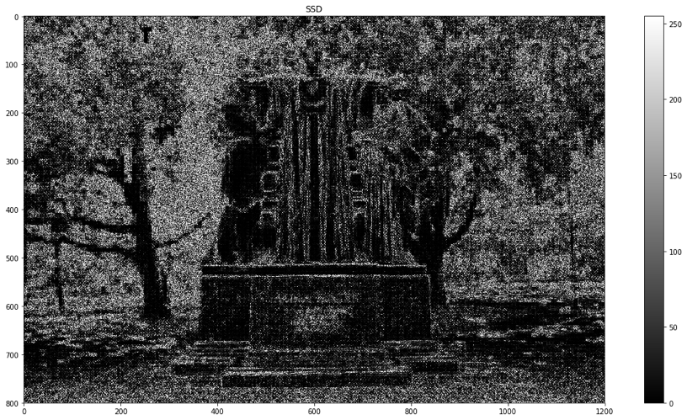

Figure 11 Color Map of Square Difference of UIUC Image with FREEMAN approach

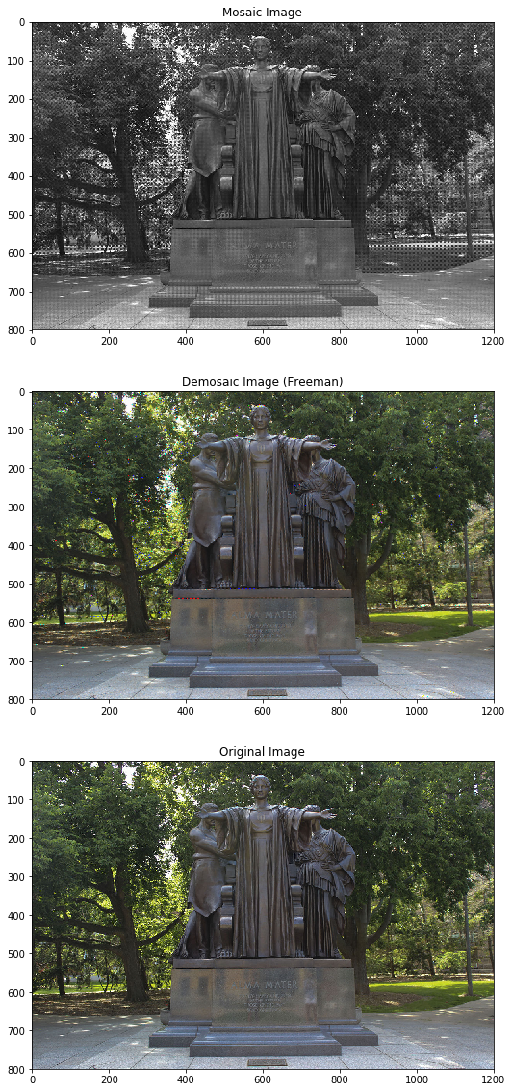

Figure 12 (TOP) MOsaic Image (Mid) Demosaic Image with Freeman Approach (Down) Original Image

1. Any image that breaks the method and why do you think so?

* The demosaic Forbbiden City image with freeman approach, in the roof region, the demosaicing resulting this purple issue stripes, and these are artifacts from the freeman method
* The demosaic UIUC image with freeman approach shows these red, blue dots, which are artifacts from the freeman method.
* This Freeman method is based on the linear interpolation, after the linear interpolation, it will based on the green channel and try to smooth out the B-G , R-G products and add the Green channel back to get the Red and Blue channel. However, we know that even the Green channels are not accurate enough, and the following steps are based on the Green channel accuracy, therefore if the green channel is more accurate in some of the images, the resuling demosaic image would be better, however if the green channel is not accurate enough, then the demosaic image would show these significant artifact.